**CMSC203 Assignment 0**

Class: CMSC203 CRN XXXX

Program: Assignment 0

Instructor: Alia Webb

Summary of Description: Several screenshots and a reflection for setting up required applications to use Java.

Due Date: 05/26/2024

Integrity Pledge: I pledge that I have completed the programming assignment independently.

I have not copied the code from a student or any source.

**Complete the following five parts of Assignment 0:**

**Part1: Setup GitHub:** Provide the screen shots of your GitHub account with Assignment 0 file is uploaded here:

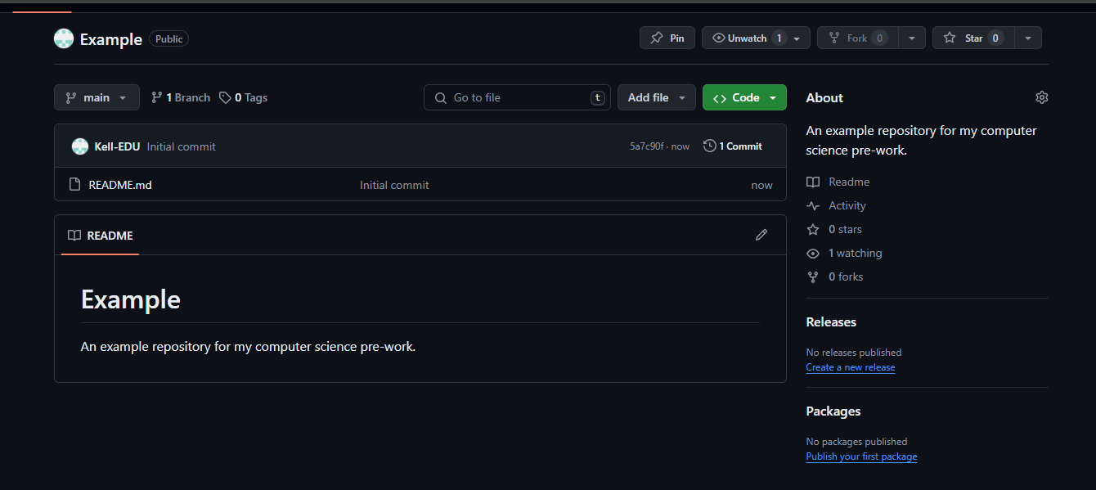

**Part 2 -Install JDK, Test java Application from Command Line**

Provide the screen shots from Step 1 and 2 here:

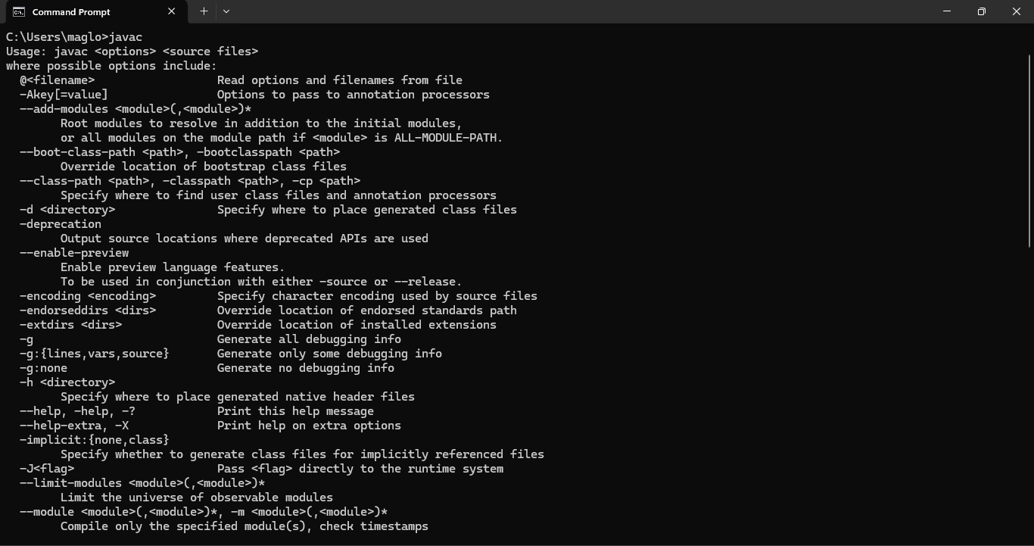

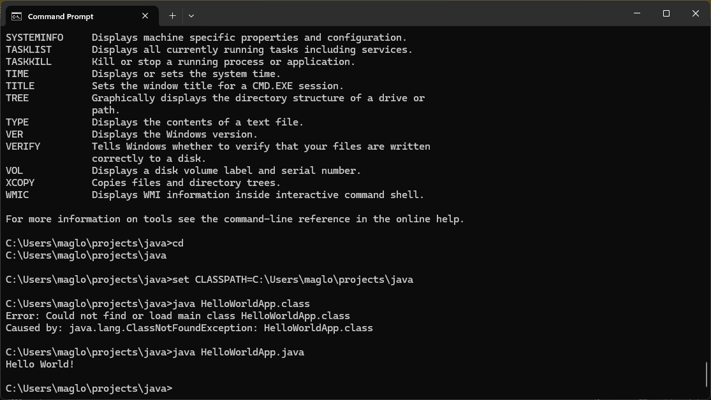

**Part 3 - Install Eclipse, Test Eclipse Java Application**

Provide the screen shots from Step 1 and 2 here:

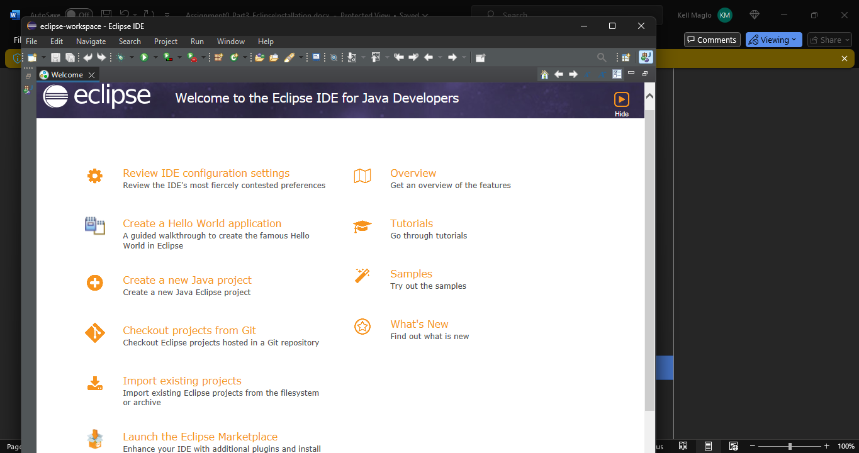

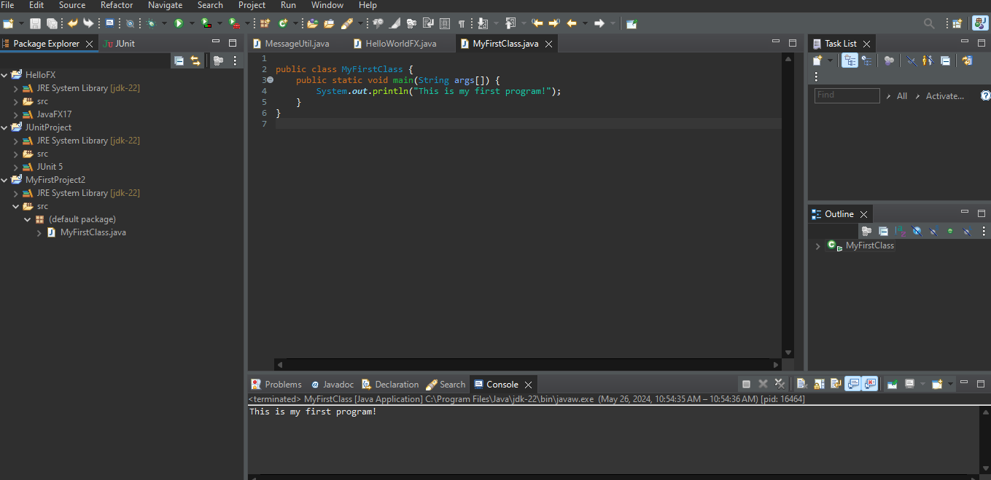

**Part 4 - Install, Setup, Test Junit Program.**

Provide the screen shots showing:

a. Eclipse with working JUnit Test example

b. Project screenshot

c. Running example screenshot

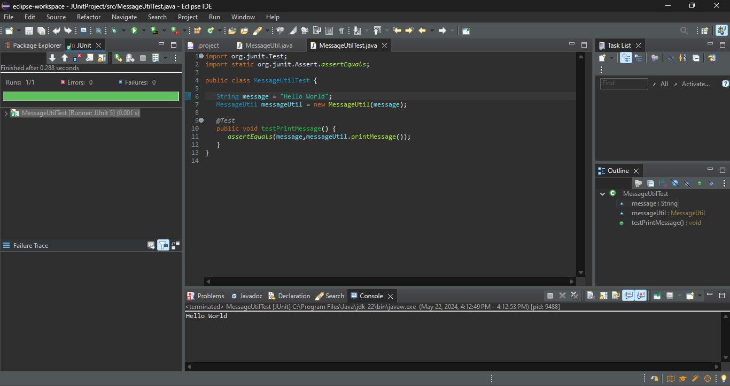

**Part 5 - Install, Setup, and Test JavaFX Application.**

Provide the screen shots showing:

a. JavaFX Project screenshot

b. Running example screenshot

c. Java Source Code File

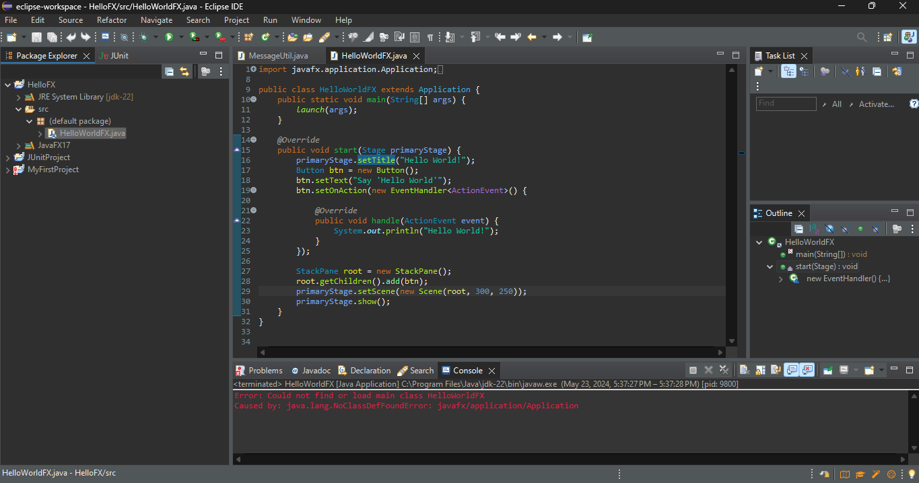

**Lessons Learned** <Provide answers to the questions listed below>**:**

Write about your Learning Experience, highlighting your lessons learned and learning experience from working on this assignment.

What have you learned?

I learned that I should be conscious with my storage space on my computer, as I am running out of it.

What did you struggle with?

Some of the instructions did not fully work for me, so I had to look to other sources to finish the assignment. For example, creating Java projects did not automatically add the Java library, so I had to figure out how to change my preferences so the projects would automatically add it.

What parts of this assignment were you successful with, and what parts (if any) were you not successful with?

I was successful with downloading all of the files that I needed. I was not successful with getting JavaFX to run.

Provide any additional resources/links/videos you used to while working on this assignment.

[openjdk - java.lang.NoClassDefFoundError: javafx/application/Application - Ask Ubuntu](https://askubuntu.com/questions/1136420/java-lang-noclassdeffounderror-javafx-application-application#:~:text=NoClassDefFoundError%3A%20javafx%2Fapplication%2FApplication%20which%20indicates%20that%20the,jre%20cannot%20find%20the%20FX%20classes.&text=NoClassDefFoundError%3A%20javafx%2Fapplication%2FApplication%20which%20indicates,find%20the%20FX%20classes.&text=which%20indicates%20that%20the,jre%20cannot%20find%20the)

<https://stackoverflow.com/questions/25166023/how-do-i-add-a-new-jre-library-in-eclipse>

**Check List:** <Provide answers to the column Y/N or N/A >**:**

| **#** |  | **Y/N** | **Comments** |
| --- | --- | --- | --- |
| **1.** | **Assignment files:** |  |  |
|  | · FirstInitialLastName_Assignment0.docx/pdf | **Yes** |  |
|  | · Source java files | **Yes** |  |
| **2.** | **Program compiles** | **Partially** | HelloworldFX does not compile |
| **3.** | **Program runs with desired outputs related to a Test Plan** | **Partially** | HelloworldFX does not compile |
| **4.** | **Documentation file: Screenshots of** |  |  |
|  | · Part1: Setup GitHub | **Yes** |  |
|  | · Part 2 -Install JDK, Test java Application from Command Line | **Yes** |  |
|  | · Part 3 - Install Eclipse, Test Eclipse Java Application | **Yes** |  |
|  | · Part 4 - Install, Setup, Test Junit Program | **Yes** |  |
|  | · Part 5 - Install, Setup, and Test JavaFX Application. | **Yes** |  |
|  | · Lessons Learned | **Yes** |  |
|  | · Checklist is completed and included in the Documentation | **Yes** |  |